**USE DASHBOARD NODES FOR CREATING UI**

|  |  |
| --- | --- |
| DATE | 19-11-2022 |
| TEAM ID | PNT2022TMID26841 |
| PROJECT TITLE | Hazardous area monitoring for industrial power plant powered by IoT |

NODE-RED NODES WITH DASHBOARD NODES:

PNT2022TMID49260

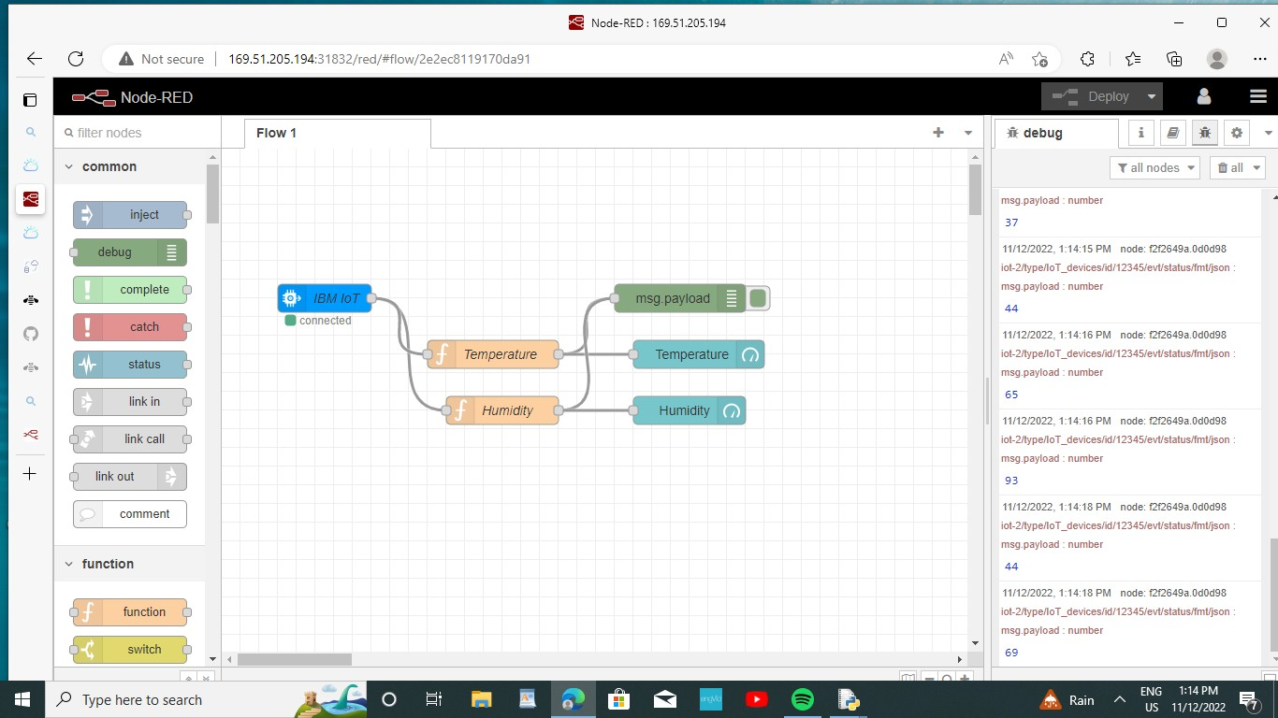

WEB APPLICATION:

